## Network

Under “Configuration > Network” the present network connections are shown (on right-hand side of window).

Select the IP-addresses of the network ports to use with the network server / client module (click and hold the Ctrl-key to select multiple network ports).

To confirm the settings, click “Accept and restart communications”.

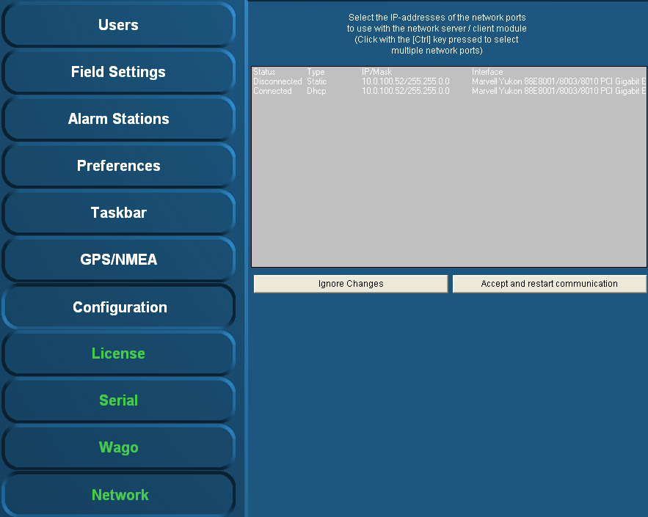

Figure 2‑37: Network

*:*

*If there is no connection between server-clients or server-server, this is the most appropriate way to check. If the network ports aren’t selected here, there is no connection possible.   
Make sure that all the network ports are selected and then acknowledge via button “Accept and restart communications”.*